

Specification

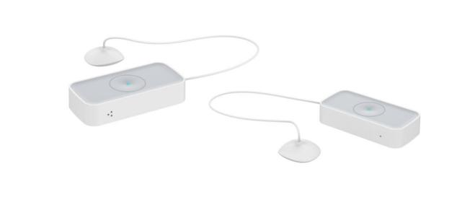

This Smart Flood Sensor, adopts ZigBee wireless module. Super low power consumption circuit design, makes long battery lifespan. Separate design of body and sensor, efficiently prevent the influence resulted from high humidity. High precision and sensitivity, applicable for basement, machine room, hotel, water tower, pool, swimming pool, solar, kitchen, bathroom and other places may have water leakage or water overflow.

***Premium Add-on device for your home***

***Features***

**Smart Flood Sensor**

* **Standard ZigBee protocol, good compatibility ;**
* **Super low power consumption design, battery lifespan can up to 1.5 years ;**
* **Seperate design for body and sensor, efficiently prevent influences resulted from high humidity ;**
* **Low power alert and report function ;**
* **Easy taking out battery and replacing battery ;**
* **Free tool installation, stick and play ;**
* **Smart and fashion design, with appearance design patent ;**
* Model Number: HS1WL-TY
* Working Voltage: DC3V
* Battery Type: 2xAAA battery
* Battery Life: 1.5 years
* Standby Current: <10uA
* Alarm Current: ≤35mA
* Networking Way: ZigBee 2.4GHz
* Wireless Distance: ≤100m (open environment)
* Working Temperature: -10℃ ～ +50℃
* Working Humidity：≤95%RH
* Body Size: 76x36.6x16.5mm
* Sensor Size: 28.3x26.5x12.2mm
* Gross Weight: 66g